St. John the Baptist School

Junior Boys
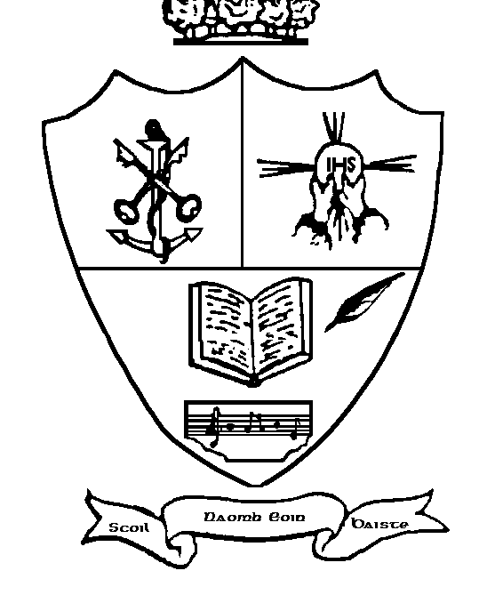
Child Protection Guidelines

School Ethos:

St John the Baptist Junior Boys School (Belgrove) is a National School under the patronage of the Catholic Archbishop of Dublin. It supports and upholds the Catholic Ethos.

Mission Statement (excerpt):

We, the staff believe that Belgrove Junior Boys N.S. should be a happy place where children can grow morally, spiritually, intellectually, emotionally and physically.

We believe that Belgrove Junior Boys N.S. should be a place where children can learn; where the atmosphere is conducive to learning; where teachers are committed, caring, encouraging and fair; where discipline is good and self-discipline is fostered; where unsocial behaviour is unacceptable and where boys are shown that aggressive behaviour is not part of growing up to be a man.

In keeping with the above, we the staff of Belgrove Junior Boys National School will do all in our power to create a safe environment for the children in our care in order to secure their protection and enable them fully to participate in the life of the School.

[Copies of the School Ethos statement, Mission statement and Aims may be had from the school secretary’s office or downloaded from the school website www.belgrovejbs.ie]

To report incidents of child abuse* or suspected abuse:-

Designated Liaison Person John O’Sullivan 8336539

Deputy Liaison Person Áine Duffy 8336539

Duty Social Worker Mountjoy Square 8556871

Gardaí, Clontarf Station 6664800

* (i.e. neglect, emotional abuse, physical abuse, sexual abuse)

