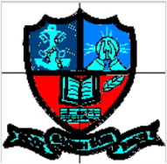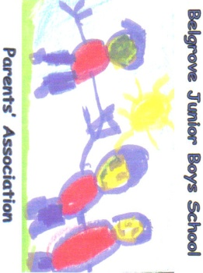

‘Treasure Boxes’

The School is facilitating the collection of ‘Treasure Boxes’ for a local charity this Christmas. The details are outlined below.

The **local** charity is a large childcare centre based in the **North Dublin** area and if you are interested in supporting here is some background directly from the Centre’s Manager.

“Our childcare centre was established 2001 and the largest of its kind in Ireland with 250 children attending daily. Our Centre operates in an area of North Dublin synonymous with unemployment, lone parents, teenage pregnancy, substance abuse and drug dealing. It is officially recognized as an area of severe social disadvantage where some children live in abject poverty. Many children in our care are missing the basics…….a bed of their own, clean underwear, food. Some deal with serious loss at an age too young to even imagine.

Our mission is to meet the community's need for high quality childcare. Childcare directed at specific problem or disadvantage benefits the child directly but also benefits the overall family as parents can attend work, training or rehab while their child is cared for in a secure environment.

Thank you so very much for considering us this Christmas at a time when our centre is experiencing severe financial difficulties. We don’t need presents that cost lots of money, what works best is 4 or 5 small items in a shoebox that make up a “treasure chest” for the younger (0 to 5 year old) children or our older after-school children (aged 5 to 10).The children at the centre range in age from 0 to 12 years with the majority being between 1 and 4 years. We have 40 after-schoolers that range in age from 5 to 12 and there is an even mix of boys and girls..**Generally a box can consist of a book, a small toy or game, an item of clothing (hat, scarf, pj’s etc) and a small packet of sweets. If you can write the age range of the child you are buying for on a sticker on the box that would help us enormously with the task of sharing out the boxes.**Ideas for the younger children's boxes might include:Cars, trucks, trains etc (some cars are for 18 months+, these are great for our younger children); Dolls, tiaras, fairies, wands, dress up toys etc; Jewellery, hand bags, nail polish (age appropriate please!!); Arts and crafts things (Crayons, Glitter glue, pencils, stickers etc); Small footballs, rugby balls etc; Play tea sets; Story books; Flashcards; Toothbrush/Kiddie Shampoo/Bath Foam; Underwear; Bath toys (ducks, boats etc); Dinosaurs, toy animals; small cuddly toys; Little figures (Bob the builder, Fireman Sam, pirates, fairies and princesses etc); Musical toys, rattles, shakers, nursery rhyme books etc………….. anything else that little people can have fun with!Ideas for the older children might include:

Hair gel, Shower Gel; Gloves; Make up sets; T-shirt; Sticker books for Star Wars, Ben Ten or Moxy Girls; Deck of Cards; Craft/Art Supplies; Harmonica; Pocket Puzzles

**If you don’t have time to make up a box we are always delighted to receive toys or equipment that can be used by all the children all year round at the centre. Ideas might include:** dolls, doll's buggies etc, lots of dress up toys, new jigsaws and board games, pirate ships and fire engines, cooking equipment (to make buns, pizzas etc with the children), gardening toys, footballs and really anything else that children like to play and have fun with.Many thanks for reading.

In the event that you choose to support us, enjoy making up your “treasure box”, the children will love opening it!!”

The date for transfer of the completed boxes from the School is **Monday, 17th Dec. 2012**.